

<Project Name/Project ID>

Project Timeline
Version X.X
DD/MM/YYYY

Document Tracking
The following chart is used to log of all changes made to this document.
Version | Date of edit/change | Who made the edit/change | Description of edit/change
0.1 | Jan 21, 2022 | Mary True (PM) | Initial version
0.2 | Jan 22, 2022 | Mary True (PM) | Modified Start and Completion dates for Cycle 1, 2, and 3.
1.0 | Jan 30, 2022 | Paul Light (Senior PM) | Final version

Introduction
Green World company is a new re-cycling concept organization based in Hong Kong which established on Jan 1, 2026.
Green World’s products were donated by the public and sold to the public with discounted price.
So far, customers need to visit the physical stores to purchase the products.
Green World would like to sell products online and would like to set up an E-shop/website to display their company’s information, product information and be able to sell products online if possible.

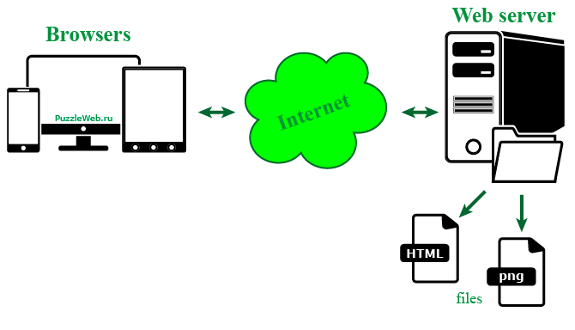

1. First iteration/cycle
Start Date: Feb 19, 2026
Completion Date: Feb 26, 2026
Stakeholders:
Requirement(s) completed:

2. Second iteration/cycle
Start Date: Feb 26, 2026
Completion Date: Mar 12, 2026
Stakeholders:
Requirement(s) completed:

3. Third iteration/cycle (Final cycle)
Start Date: Mar 19, 2026
Completion Date: Apr 2, 2026
Stakeholders:
Requirement(s) completed:

4. Concerns and Issues

